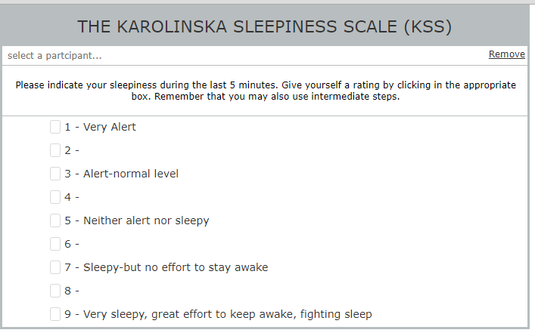

The Bear is asleep and is at the very end point of this sleepiness scale!



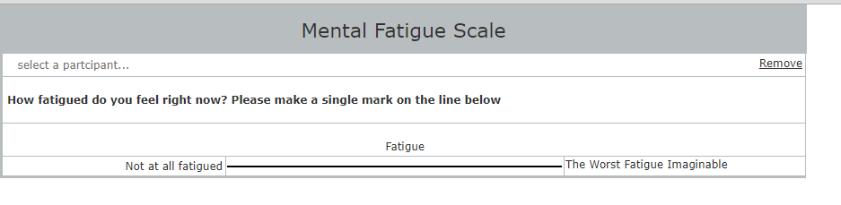



The Lion is very fatigued – awake -no energy - but not sleepy